**The Clinical School Wellbeing Programme**

Launched in April 2015, Year 1 of the Wellbeing Programme focused on embedding a culture of dignity in mental health at work and established the **Cambridge Biomedical Campus Wellbeing Network** (**CBCWN**) This uniteslocal private and public sector organisations around a shared vision of wellbeing. Members include the Cambridge University Health Partners (CUHP), ([Cambridgeshire and Peterborough NHS Foundation Trust](http://www.cpft.nhs.uk/), Cambridge University Hospitals NHS Foundation Trust, Papworth Hospital NHS Foundation Trust), AstraZeneca, GlaxoSmithKline, MRC and MIND. The CBCWN meetings foster collaboration and sharing best practice on wellbeing initiatives.

The School has promoted the following objectives through different activities:

**To increase the confidence of employees and students, thus enabling them to discuss mental health issues freely within the workplace**

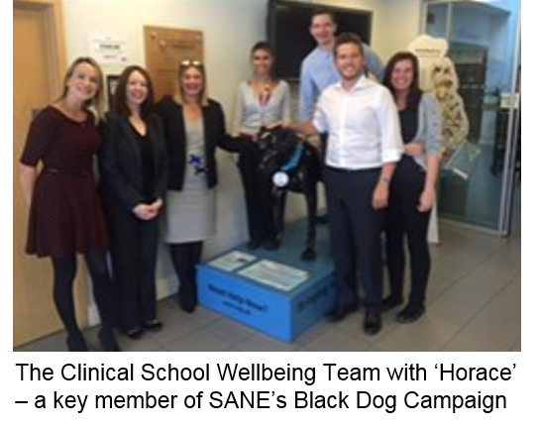•         More than 1,600 staff have attended a series of 36 topic briefings, ranging from Mental Health Awareness, Mindfulness, Relaxation, Diabetes, Dementia, to mental health conditions such as Psychosis, Stress and Personality Disorders. These have drawn on the expertise of clinicians on the Biomedical Campus, as well as external organisations such as Macmillan Supporting Cancer at Work and SANE’s ‘Horace’ the Black Dog Campaign;

* Each year the School holds daily events during Mental Health Awareness Week –including talks from Dame Carol Black, Professor Peter Jones, a Benefits and Wellbeing Roadshow and having a “MIND Tree” ;
* The School actively promotes Random Act of Kindness Day and other relevant national events.

**To provide appropriate training and support for managers and supervisors so they feel able to discuss concerns with and provide support to employees and students**

* Collaborating with MIND in Cambridgeshire, 162 School employees have completed Mental Health LITE training;
* The School has established a Mental Health First Aider service – 16 new First Aiders have been trained through MIND’s two-day Mental Health First Aider course;
* Provision of Suicide Prevention training for Equality Champions and Mental Health First Aiders;

The School has signed the STOP Suicide Organisational Pledge, in support of the Cambridgeshire and Peterborough STOP Suicide Campaign.

**To highlight the availability of effective interventions to managers, staff and students through increased and prominent of information**

* Benefits and Wellbeing Notice Boards in every School department display details of Wellbeing Programme events – these are regularly updated with new material and distribute resources such as MIND leaflets and over 600 crisis cards;
* Quarterly Wellbeing Newsletters and the Clinical School Wellbeing webpages provide topic-specific information, event details and contact details for both internal and external support services.

In Year 2 (April 2016 to March 2017) we broadened the scope of the programme to ensure equal parity between mental and physical health, moving in Year 3 (April 2017 to March 2018) to emphasise the ‘doing’ from exercise to volunteering. Looking beyond illness to health, staff have been encouraged to undertake five actions known to promote wellbeing: connect; be active; take notice; keep learning; and give. By linking these actions to existing University benefits and services – e.g. sports facilities and opportunities for continued learning, we hope that School staff will take simple steps to contribute to their wellbeing. As such, our Programme now includes:

* The Clinical School Wellbeing Week has included a Pedometer Challenge, Smoothie Bikes and a British Heart Foundation Event, with external visitors such as Jonny Benjamin and Rachel Kelly;
* 10 Botanical Garden membership passes will be provided for staff and their families to share;
* Twice weekly yoga and Pilates sessions to be provided free of charge at the School;
* This year’s Mental Health Awareness Week, with a theme of ‘Surviving or Thriving’, will include guest speakers including Anne Bailey from ‘From the Future’ on volunteering.

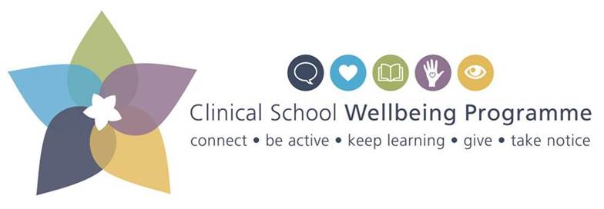The Wellbeing Programme’s new logo